Chapter 8, Solution 40.

The switch in the circuit of Fig. 8.88 is moved from position a to b at t = 0. Assume that the voltage across the capacitor is equal to zero at t = 0 and that the switch is a make before break switch. Determine i(t) for all t > 0.

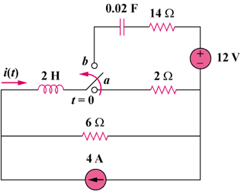

Figure 8.88
For Prob. 8.40.

Solution

At t = 0-, v_{C}(0) = 0 and i_{L}(0) = i(0) = (6/(6 + 2))4 = 3A

For t > 0, we have a series RLC circuit with a step input as shown below.

14 Ω

i

24V

2 H

0.02 F

12V

+
−
+ −

6 Ω
+ −

v

ω_{o} = 1/ = 1/ = 5

- = R/(2L) = (6 + 14)/(2x2) = 5

Since α = ω_{o}, we have a critically damped response.

v(t) = V_{s} + [(A + Bt)e^{-5t}], V_{s} = 24 – 12 = 12V

v(0) = 0 = 12 + A or A = -12

i = Cdv/dt = C{[Be^{-5t}] + [-5(A + Bt)e^{-5t}]}

i(0) = 3 = C[-5A + B] = 0.02[60 + B] or B = 90

Thus, i(t) = 0.02{[90e^{-5t}] + [-5(-12 + 90t)e^{-5t}]}

i(t) = {(3 – 9t)e^{-5t}} A

